Product Name: Brand Dater
Product Type: Dating App based on Fashion
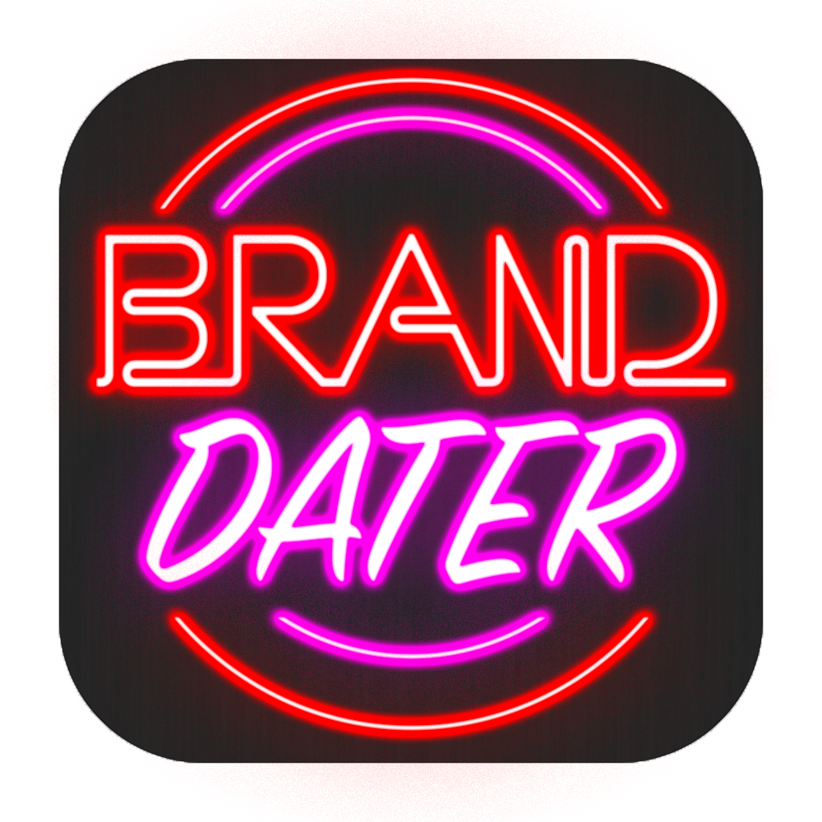
‘Brand Dater’ is based on the growing popularity of casual fashion in the 21st century, and how young people value a sense of style and fashion to shape their identity. Unlike other dating apps, ‘Brand Dater’ is all about allowing people with a similar sense of style to meet and date, thus allowing people to share their identity with a likeminded and similar partner.

The logo is based off an old-school neon sign that you may see in a vintage clothes store to really give a focus on the fashion and aesthetic side of things.

Target Group: People aged 18 (Minimum age to sign up for a dating site) to mid 20s/ early 30s. These groups are more likely to be into streetwear fashion as they don’t necessarily have to spend income on a mortgage, kids etc.

Features: Will be fully app based to reinforce the idea that this product is for young adults, as this group will likely be more tech savvy. Additionally, this app can range from dating to hook-ups, but the goal would be for it to be considered a bona-fide dating app as many other dating apps (such as Tinder) and predominantly used for hook-ups. This app would work through users selecting brands and aesthetics that they like, as well as how far away people are and their age range, and then would work off of a similar ‘swipe’ system to Tinder (obviously with small changes to Tinder’s formula as I believe it is patented). There would then be the normal chat feature that appears etc.

Unique Selling Point(s): There are no dating sites currently based on streetwear and people’s personal aesthetics, and with the huge popularity of Instagram and ‘hypebeast’ fashion, I believe that this has potential to hit an area of the market rich with opportunity. Additionally, the focus of this site will be around meaningful relationships, not just hook-ups, which differs to the majority of popular dating sites on app stores.

Money: The app would be free, however premium features such as how many brands you can choose for your profile, seeing people that have liked you, etc. will be premium features which cost a monthly fee of £4.99.

Competition: Tinder is the obvious competition here as they have a hold on the online dating market. ‘Brand Dater’, however, hits a gap in the market for people interested in fashion above all else. Additionally, we can use Tinder to our advantage by suggesting that people who have had difficulty finding on a match on there would be able to try this site, thus appealing to a market disillusioned with Tinder. Additionally, we will be in competition with apps such as Grindr as this app will be for people of ALL sexual orientations. Grindr is much more of a hook-up site however, and so the appeal to ‘Brand Dater’ may also be that it creates meaningful relationships rather than potentially leaving people feeling like they’ve been used.

Campaign – Print Advert:
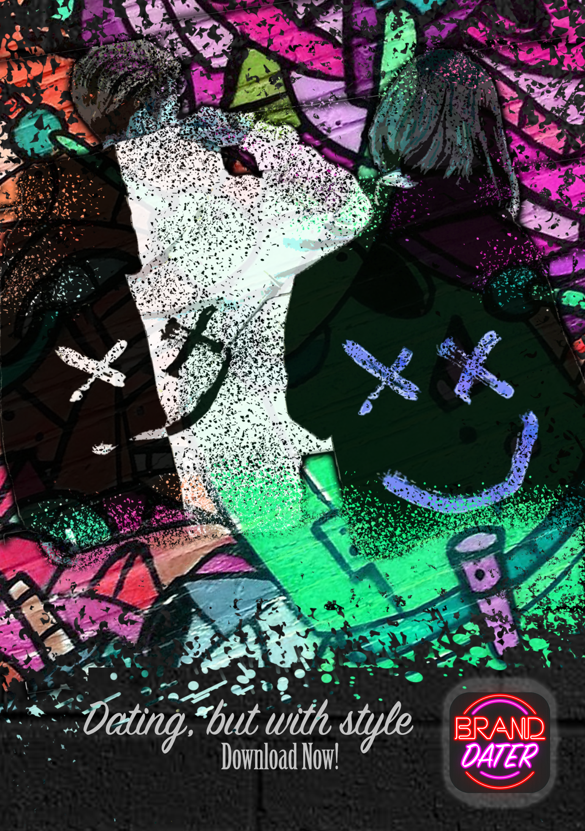
This print advert shows a fashionable couple as a piece of graffiti, showing not only that it is for a dating app, but a place for fashionable people and gives a sense of a young, creative, and vibrant community, thus showing our target demographic.
Print adverts may not be the best format for a young audience as they may use new media over traditional media, however this advert could be effective if used in magazines tailored to young people or in fashion magazines (which would be relevant to the theme of the app).

Video Advert:

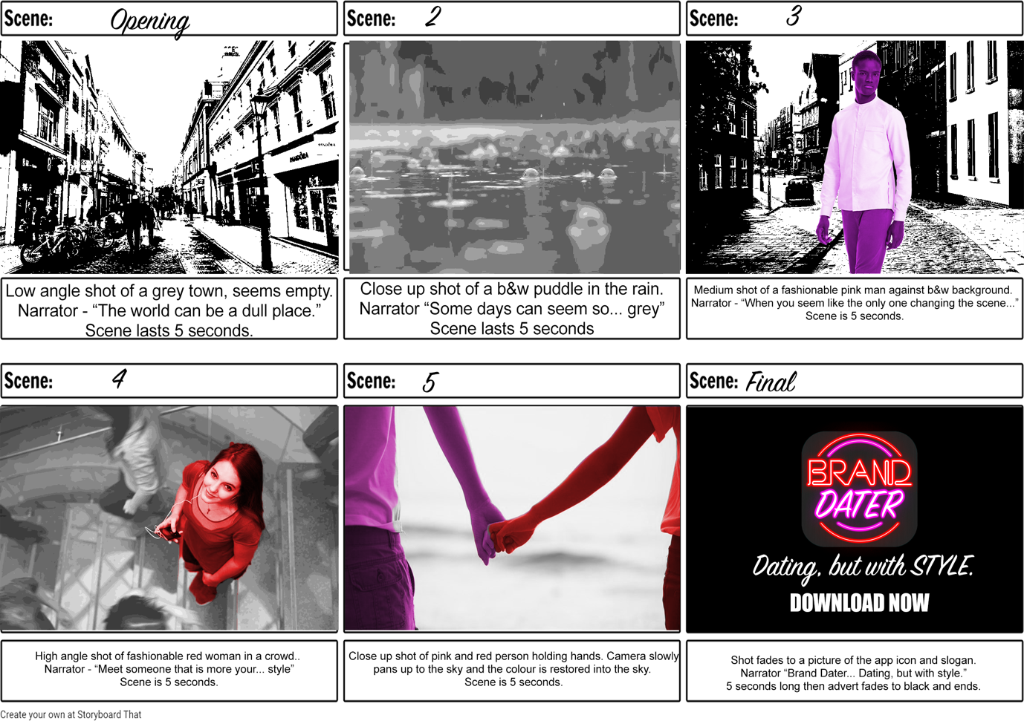

This is a storyboard about how the video advert would work. Unfortunately, as this is a one-person project, I was unable to create an example of what this would look like in a video form.
I chose to use the colours of the app logo with 2 vibrant people standing out against a black and white background. This creates a sense of standing out from the norm which is why some people embrace fashion. There would also be multiple adverts which would be identical, however would feature couples of different sexualities such as a homosexual couple in order to show a sense of diversity. These adverts would be completely identical other than the cast and shown randomly throughout ad breaks to truly normalise different types of couples. The advert is 30 seconds so could be shown at the start of YouTube videos, however this 30 second version would most often be shown in ad-breaks after the watershed to reinforce the idea that only people 18+ can join.

Digital Strategies:

‘Build Your Own Ads’– We would create short adverts on sites such as YouTube/ All4, and the adverts would all begin with a screen saying - “choose your clothing style”, pick your gender and sexuality etc. Once clicked on, an advert featuring a person’s choices would be shown. This means the advert is seemingly tailored to every single viewer, and thus creates a more interpersonal connection with an audience.

Ads on Websites – A banner advert with a short animation could be shown on websites at the top as a banner. This banner would show the app logo as well as the slogan “Dating, but with STYLE”. This banner could also be converted into a square 1:1 ratio animation to be shown on social media timelines such as Twitter or Facebook.

Social Media – This app would have a social media team that would be active on sites such as twitter. This would not only allow a PR team for social media to create publicity through having an online presence. Additionally, this would allow the social media team to reply to users and create a sense of interaction and community/.

Colours:

